**SECTION A**

1. Work out: 491 – 211

1. Write 202020 in words.

1. If x increased by 20%, it becomes 600. Find the value of x.

1. On the venn diagram below, shade n(AB)

n(A) n(B)

1. Find the next number in the sequence below

0, 2, 2, 4, 6, 10, 16, ______________

1. Solve: 8q + 6 = 30.
2. The time now is 10:30p.m. After how many hours will it be 3:00am?

1. Study the figure below carefully and find the direction of B from A.

**N**

**A** 1100

**B**

1. Find the number that has been expanded below

(4 x10**-3**) + (8 x 10**-2**) + (3 x 10**-1**)

1. Find the number that is exactly half way been 40% and 0.8.

1. If 1000 is added to 254, the result is a whole number. Express the result in scientific notation.
2. Workout: 3 – 7 = ___________ (finite 12)
3. Given that a = 0.25, b = 0.25 and c = 0.75. Find the value of .

1. Simplify: **-**2 - **-**4 – 6

1. If the range of 30, 40, 20 and 80 is x + 40. Find the value of x.

1. The perimeter of the figure below is 24cm. Find its area.

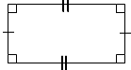

5cm

1. At Keko Primary school,  of the teachers are female and  of the females are below 30 years. What fraction of the female teachers are above 30 years?

1. Using a pair of compasses, a ruler and a pencil only, construct an angle of 1500.

1. Express 10km as Hectometres.

1. Name the polygon below

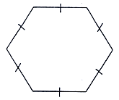

**SECTION B (60 MARKS)**

1. After covering 120km, Jesca had 40% of her journey remaining to be covered in 2 hours. Calculate her average speed for the whole journey if she travelled at a constant speed. (5 marks)

1. a) Workout: 2482 x 24 (2marks)

b) Use distributive property to find the value of (200÷ 5) + (300 ÷ 5) (2marks)

1. The venn diagram below shows the number of players who play different games in a school team. Some players play Football(F), others play Net ball (N) while the rest play other games. Use it to answer the following questions.

**n(F) n(N)**

20+y y 2y

4+y

1. If 30 players don’t play Netball at all. How many players play Netball? (3marks)

1. How many players are in the school team? (2marks)

1. The figure below shows a cylindrical metallic tank. Study it and use it to answer the following questions.

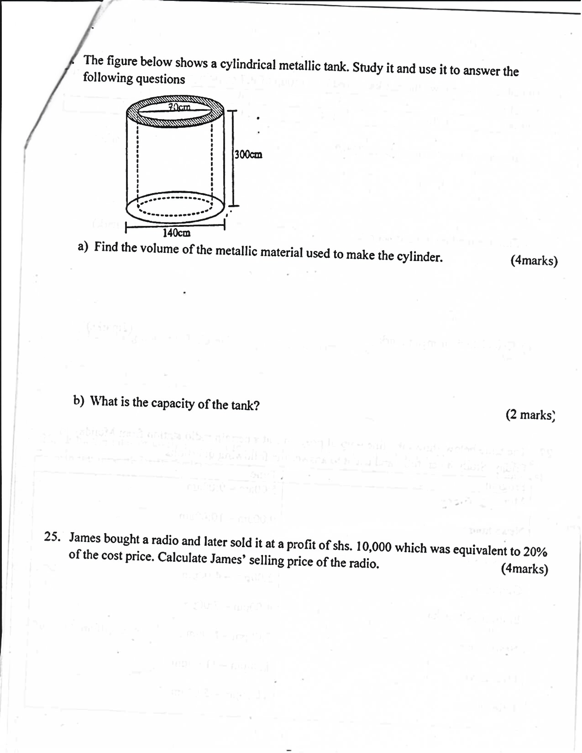

1. Find the volume of the metallic material used to make the cylinder. (4marks)

1. What is the capacity of the tank? (2marks)

1. James bought a radio and later sold it at a profit of shs.10,000 which was equivalent to 20% of the cost price. Calculate James’ selling price of the radio. (4marks)
2. The table below shows the marks scored by a group of P.7 boys in end of term 1 examination.

|  |  |  |  |  |
| --- | --- | --- | --- | --- |
| No. of pupils | 2 | 3 | 4 | 1 |
| Marks | 70% | 80% | 60% | 90% |

1. How many boys scored above 70%? (2marks)

1. Find the median in their scores (1mark)

1. Calculate their mean mark. (2marks)
2. The table below shows the line- up of programs at a certain radio station from Monday to Friday. Study it carefully and use it to answer the following questions: -

|  |  |
| --- | --- |
| **Program** | **Time** |
| Morning Glory | 5:00am – 9:00am |
| News hour | 9:00am – 10:00am |
| Music Extra | 10:00am – 2:00pm |
| Olutindo | 2:00pm – 4:00pm |
| Embeera y’amaka | 4:00pm – 7:00pm |
| News hour | 7:00pm – 8:00pm |
| Over drive | 8:00pm – 11:00pm |
| Lala Salama | 11:00pm – 5:00am |

1. At what time does Over drive program end in 24-hour clock system? (2marks)

1. If the moderator of Morning Glory Program is paid shs. 50,000 per hour, how much money does he earn in one week? (2marks)

1. How long does the Lala Salama program last? (2marks)
2. Find the interior angle sum of a regular polygon given that it’s interior and exterior angle are in the ratio of 2:1 respectively. (5marks)

1. a) Simplify: 2xy + 2x – 3xy – x (2marks)

b) Solve: 40 **<** 2t + 10 (2marks)

1. Dorcas intended to construct a square ABCD of length 5cm. she starts her diagram as shown below. Use a pair of compasses, a ruler and a pencil only to complete Dorcas’ diagram correctly.

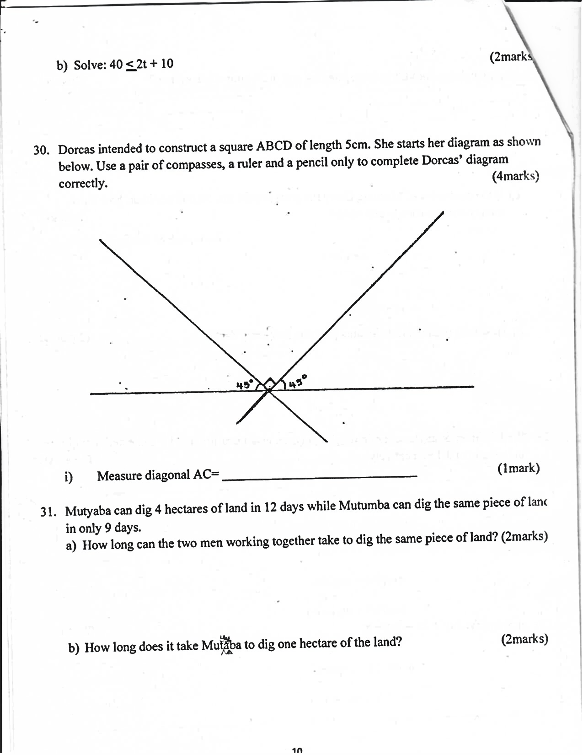

Measure diagonal AC= ____________________________ (1mark)

1. Mutyaba can dig 4 hectaresd of land in 12 days while Mutumbas can dig the same pieces of land in only 9 days.
2. How long can the two men working together take to dig the same piece of land?

(2marks)

1. How long does it take Mutyaba to dig one hectare of the land? (2marks)

1. Who is stronger of the two men? (1mark)
2. a) Write down the inverse co-ordinates of the points that form the figure shown on the grid below. (3marks)

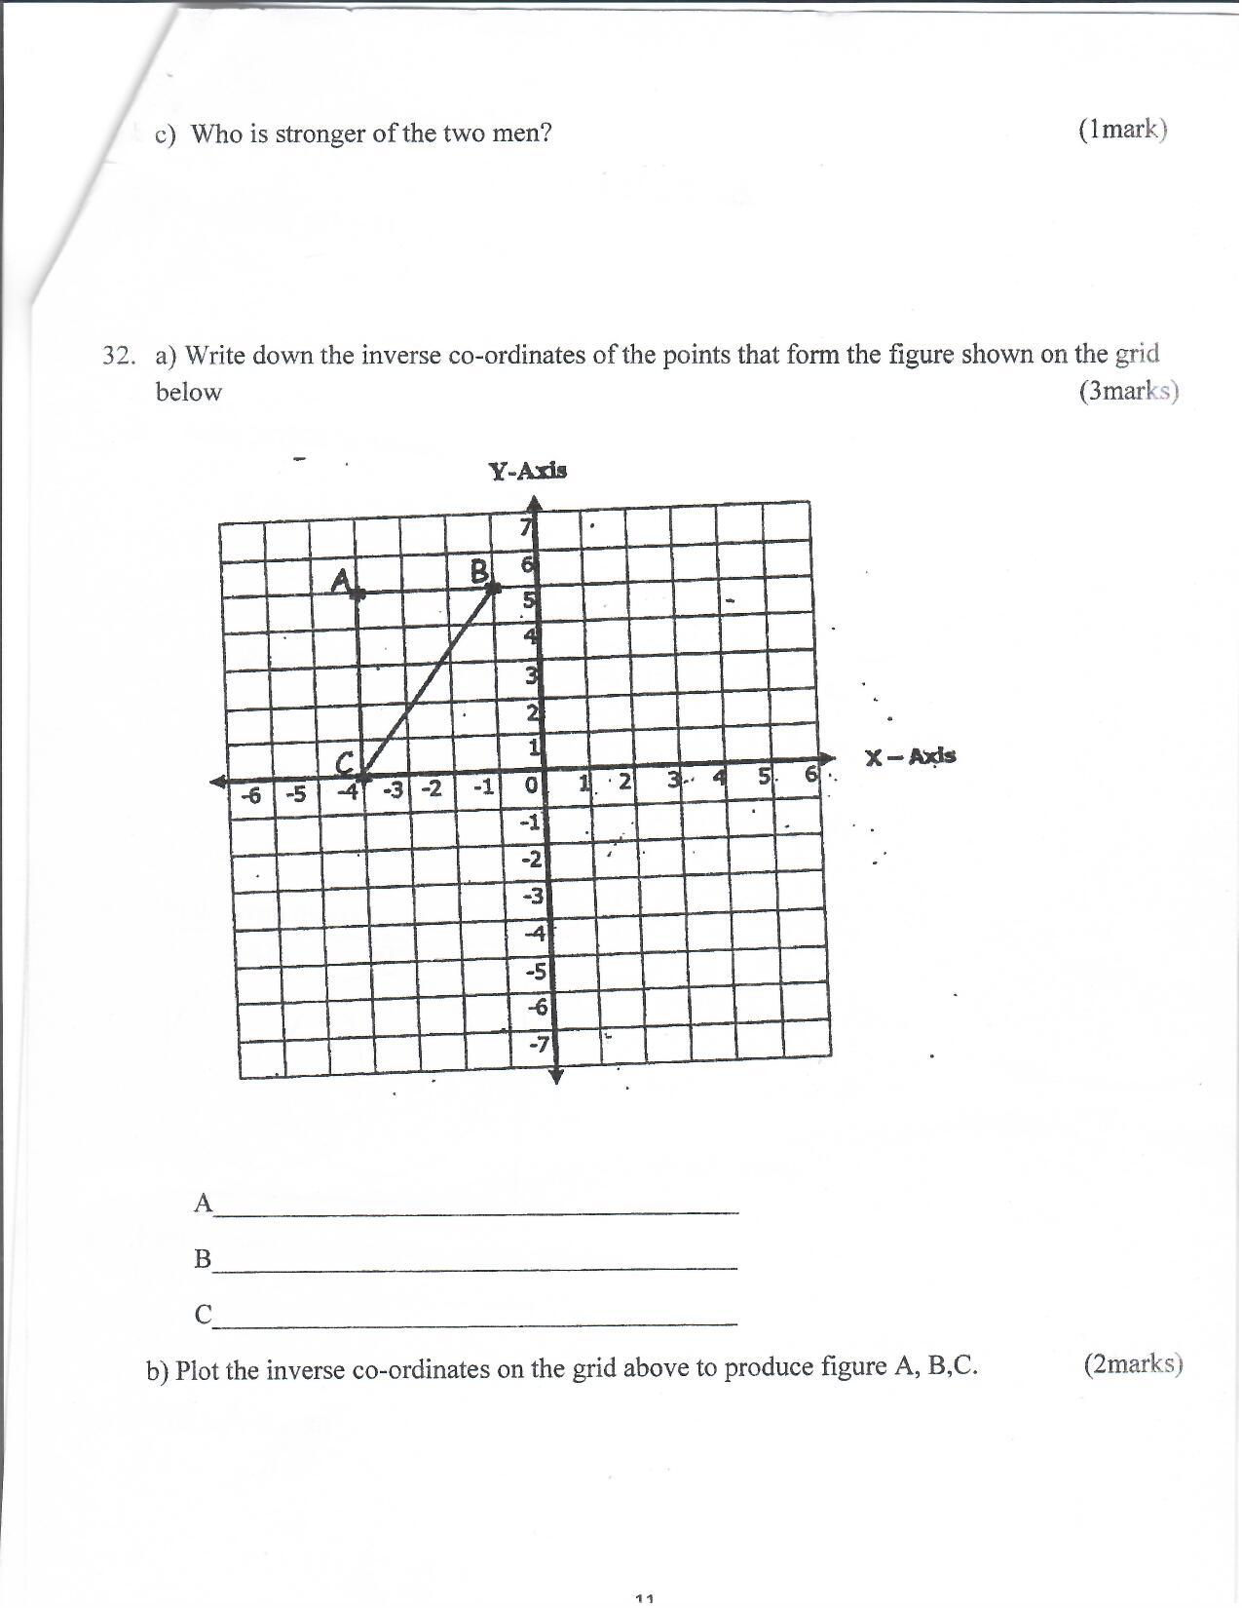

A______________________________________

B______________________________________

C______________________________________

b) Plot the inverse co-ordinates on the grid above to produce figure A, B,C. (2marks)